**For Admin deployment**

URL: 10.150.200.52

Credentials: root/mise2@.

Goto eclipse CVS Repository.

Configure CVS in your ecplise

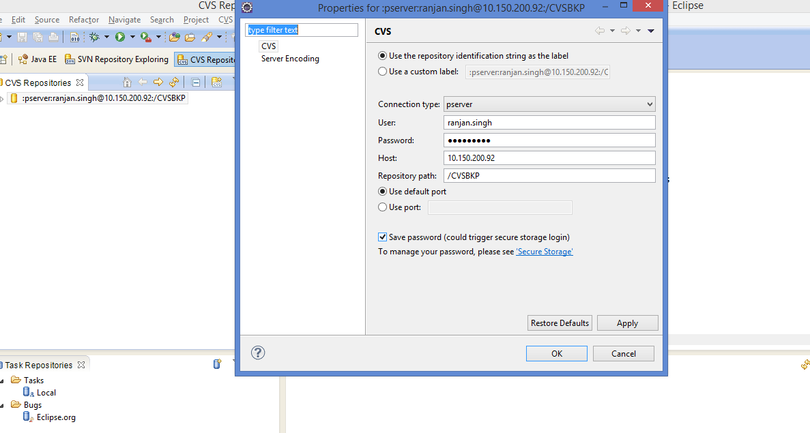

Explode and search the tag released by tech in the tjcandidate-admin folder.

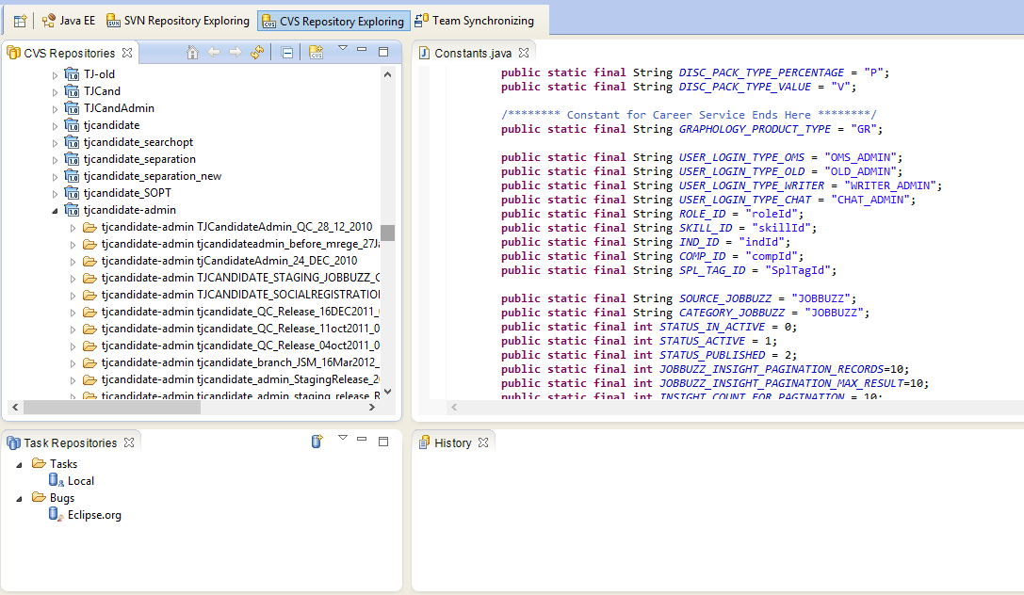

No file changes in required in QC deployment.

Once checkout is done to create a build user need to goto javaEE and select the checkedout tag and explode and select build.xml. right click build.xml and run as ant build.

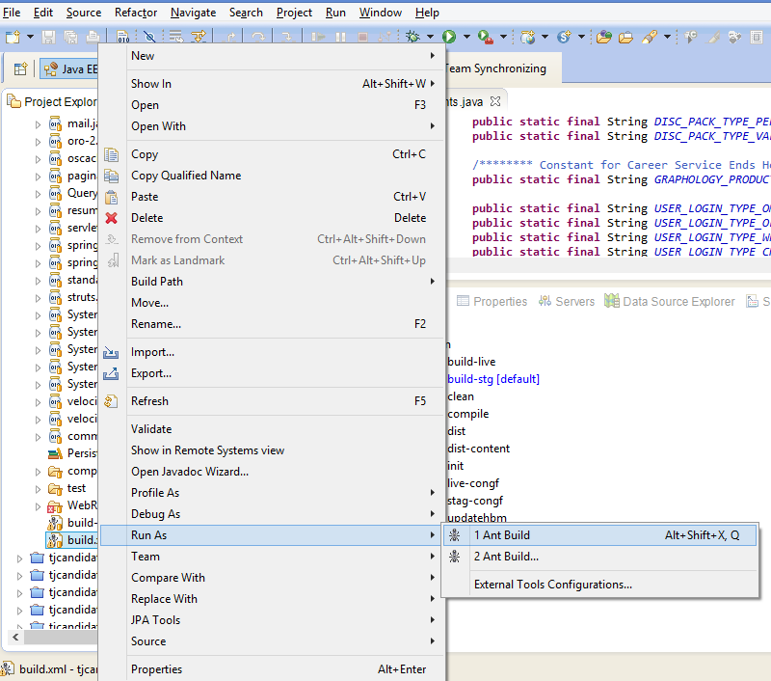

After successful build creation in user local workspace do the below mentioned steps

go to winscp

login to the server.

/opt/tomcat/webapps

go to putty

for taking backup of admin tag:-

mkdir /opt/backup/staging24feb2015

cp -r /opt/tomcat/webapps/tjcandidate-admin/ /opt/backup/staging24feb2015/

cd /opt/tomcat/webapps

rm -rf tjcandidate-admin

mkdir tjcandidate-admin

cd tjcandidate-admin

copy from console (tjcandiate.war)

cd /opt/tomcat/webapps

cd tjcandidate-admin

jar -xvf tjcandidate-admin.war

rm tjcandidate-admin.war

Y

restart command:-

ps -ef|grep tomcat

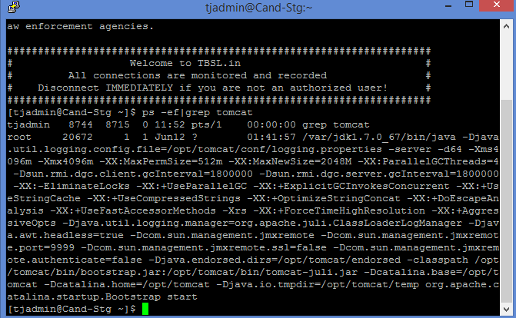

kill -9

/opt/tomcat/bin/startup.sh

**Staging Admin Build deployment.**

**URL: 115.112.206.81**

**Credentials: tjadmin/tjadmin123**

All steps remain same checkout the tag with tag name shared by tech team.

Only One file changes required for staging admin deployment.

**for 81 admin only in constant.java file** change

uncheck the lines

public static String APACHE_ROOT_URL = "http://candstaging.timesjobs.com/";

public static String ROOTURL="http://candstaging.timesjobs.com/tjcandidate-admin/";

public static String CONTEXTROOTURL="/tjcandidate-admin/";

public static String CSSROOTURL="/css/";

public static String IMAGEROOTURL="/images/";

public static String JSROOTURL="/scripts/";

public static final String GREYBOX_CSSROOTURL = "";

public static final String GREYBOX_JSROOTURL = "";

public static String DOMAIN_URL="http://candstaging.timesjobs.com/";

//Staging URL

public static final String NAF_URL = "http://115.112.206.81/naf/";

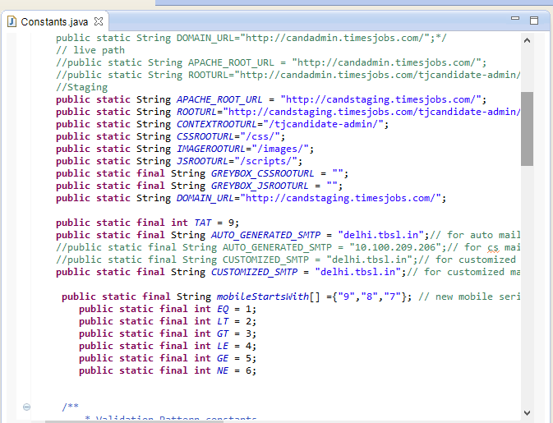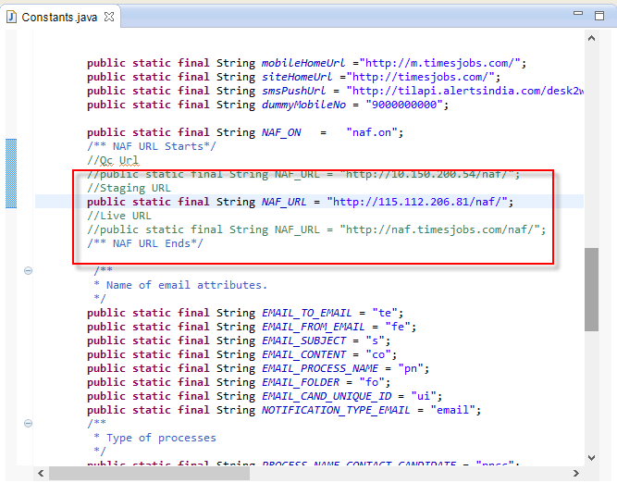

for 81 and 102 staging admin

in winscp

/opt/tomcat/webapps/tjcandidate-admin

in putty

cd /opt/tomcat/webapps

for admin backup

mkdir /opt/backup/7jan2015

cp -r /opt/tomcat/webapps/tjcandidate-admin/ /opt/backup/7jan2015/

rm -rf tjcandidate-admin

mkdir tjcandidate-admin

copy dist tjcand.war to /opt/tomcat/webapps/tjcandidate-admin

cd tjcandidate-admin

type jar -xvf tjcandidate-admin.war

rm tjcandidate-admin.war

y

Restart Server.

ps -ef | grep java(tomcat)



sudo kill -9 id

sudo /opt/tomcat/bin/startup.sh

**View Log file for any exceptions**:

Cmd: tail –f /var/lob/cslogger.log